Project No-16
Title- Write off of computational data
Schema:
faculty data - Staff_info(Title,firstName,middleName,lastName,DEPARTMENT,EMAIL_ID,PHONE_NO,ROOM_NO,Graduate (UG),Postgraduate (PG),Doctorate (Ph.D.),AREA OF SPECIALIZATION)
printer_issue_detail(Title,firstName,middleName,lastName,EMAIL_ID,ROOM_NO,Designation,Printer_model,Date_of_last_refil,Status,Priority)

AIM:
Testing of database Project created in Practical -5.

PROCEDURE:
Step-1: Select the database created in practical-5 i.e faculty from left side of the page.

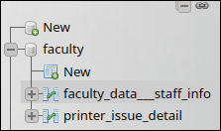

Step-2: Open first table and go to SQL to perform queries
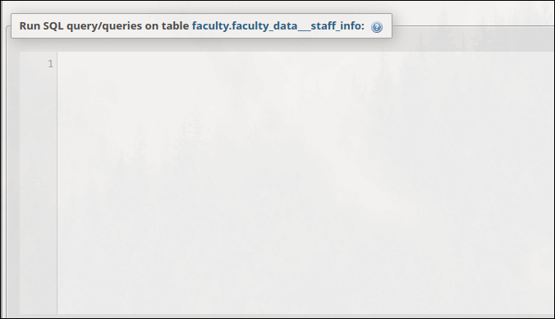

Query-1: Select operation
SELECT * FROM `faculty_data___staff_info`

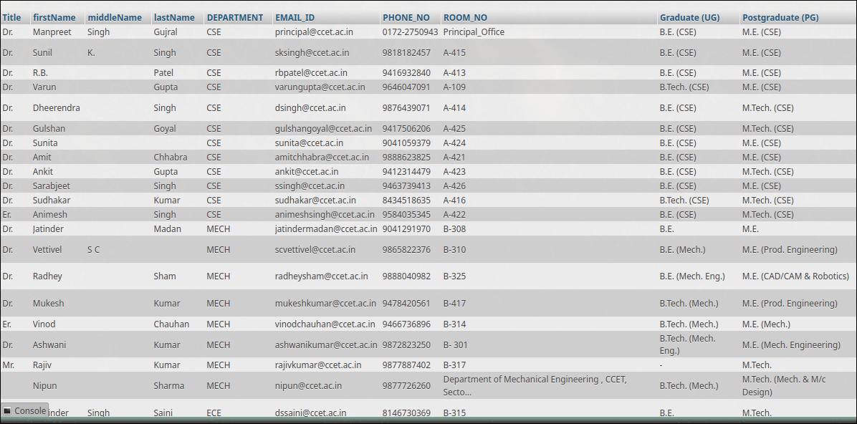
Query-2: Delete tuple
DELETE FROM `faculty_data___staff_info`
WHERE PHONE_NO=9818182457

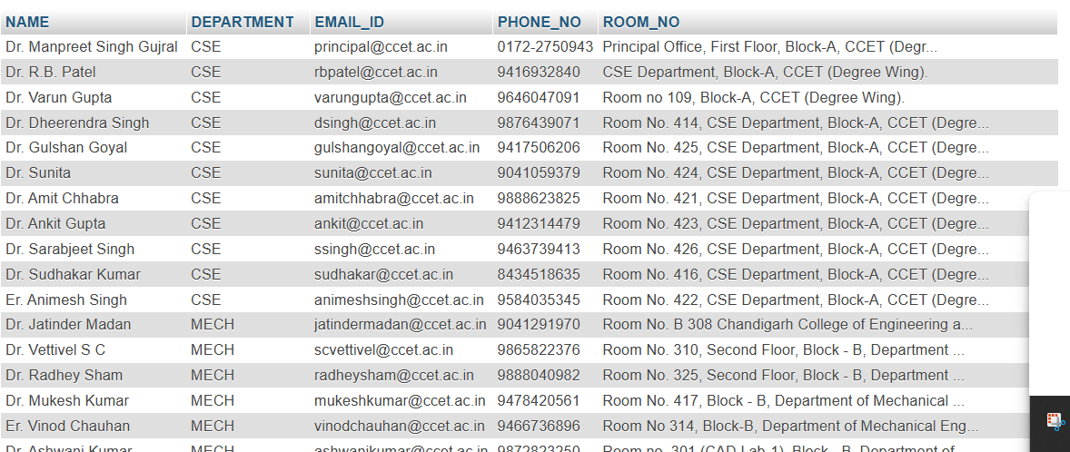
Table after deletion

Query-3: Insert operation
INSERT INTO `faculty_data___staff_info`(`NAME`, `DEPARTMENT`, `EMAIL_ID`, `PHONE_NO`, `ROOM_NO`) VALUES ('[value-1]','[value-2]','[value-3]','[value-4]','[value-5]')
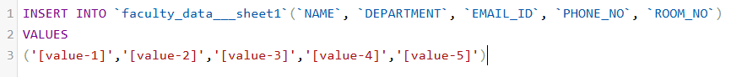

Table after insertion
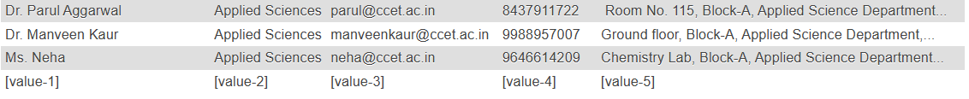

Query-4: Update operation
UPDATE `faculty_data___staff_info`
SET PHONE_NO = 12345
WHERE NAME = `[value-1]`

Table after updation

Query-5: Group-By
SELECT * FROM faculty_data___staff_info
GROUP BY DEPARTEMENT

Table after operation

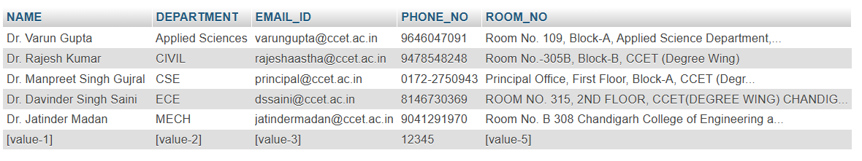

Query-6: Order operation(asc or desc)
SELECT * FROM faculty_data___staff_info
ORDER BY PHONE_NO ASC

Table after asc
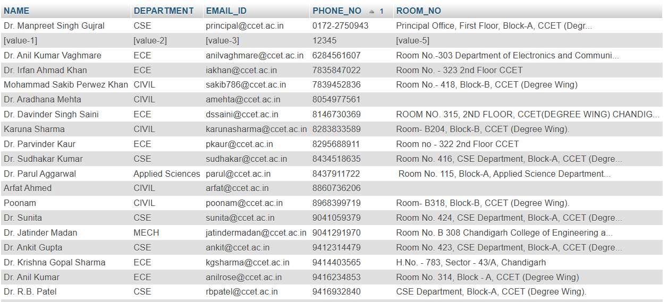

Query-7: Distinct operation
SELECT DISTINCT DEPARTEMENT
FROM faculty_data___staff_info

Table after operation
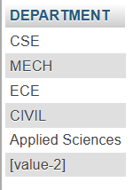

Query-8: Where operation

SELECT `NAME` FROM faculty_data___staff_info
WHERE DEPARTEMENT = ‘CSE’
Table after operation
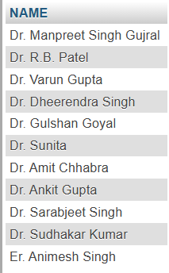

Operations on multiple tables
Query-9: Union of two tables
SELECT NAME,DEPARTEMENT
FROM faculty_data___staff_info
WHERE DEPARTMENT = ‘CSE’
UNION
SELECT NAME,DEPARTMENT
FROM printer_issue_detail
WHERE DEPARTMENT = ‘CSE’
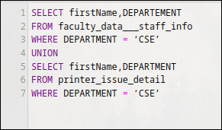

Query-10: Count operation on table 2
SELECT COUNT(NAME) FROM faculty_data___staff_info
WHERE DEPARTMENT = ‘MECH’

Table after operation

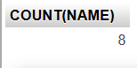

Query-11: Join operation
SELECT SHEET2.*,SHEET1.*
FROM faculty_data___staff_info AS SHEET1
JOIN printer_issue_detail AS SHEET2
ON SHEET2.NAME = SHEET1.NAME;

Table after joining
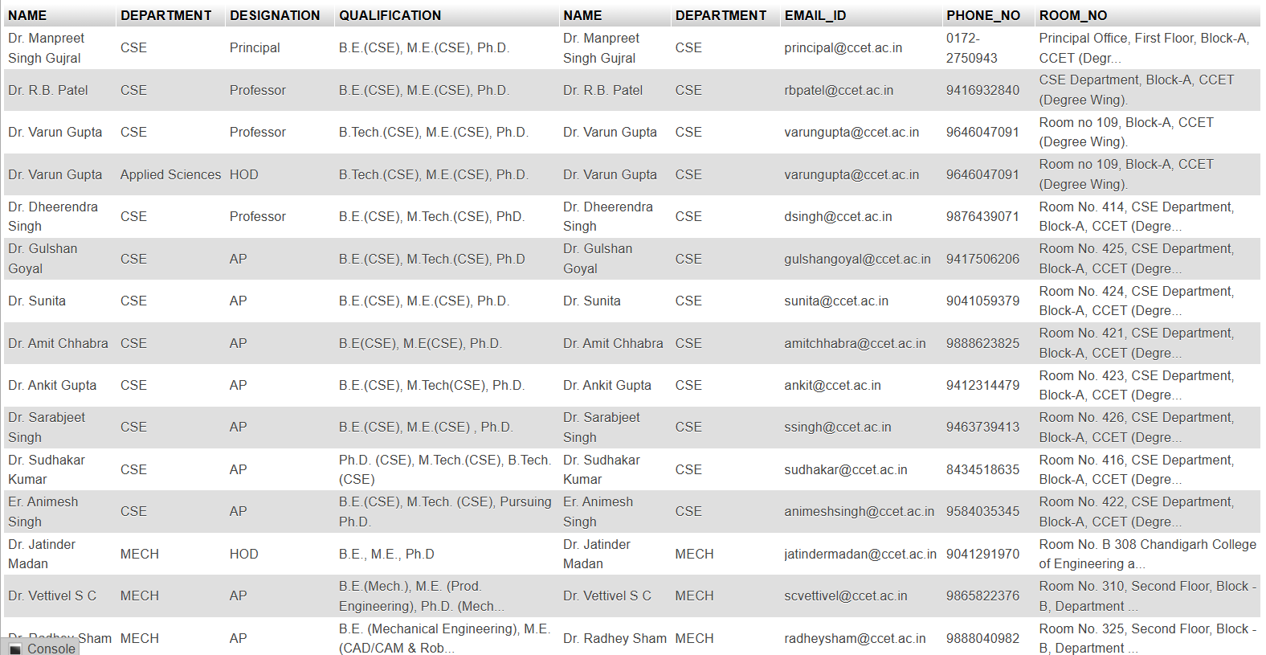

Query-12: Cartesian product
SELECT *
FROM faculty_data___staff_info
CROSS JOIN printer_issue_detail
Table after cross join

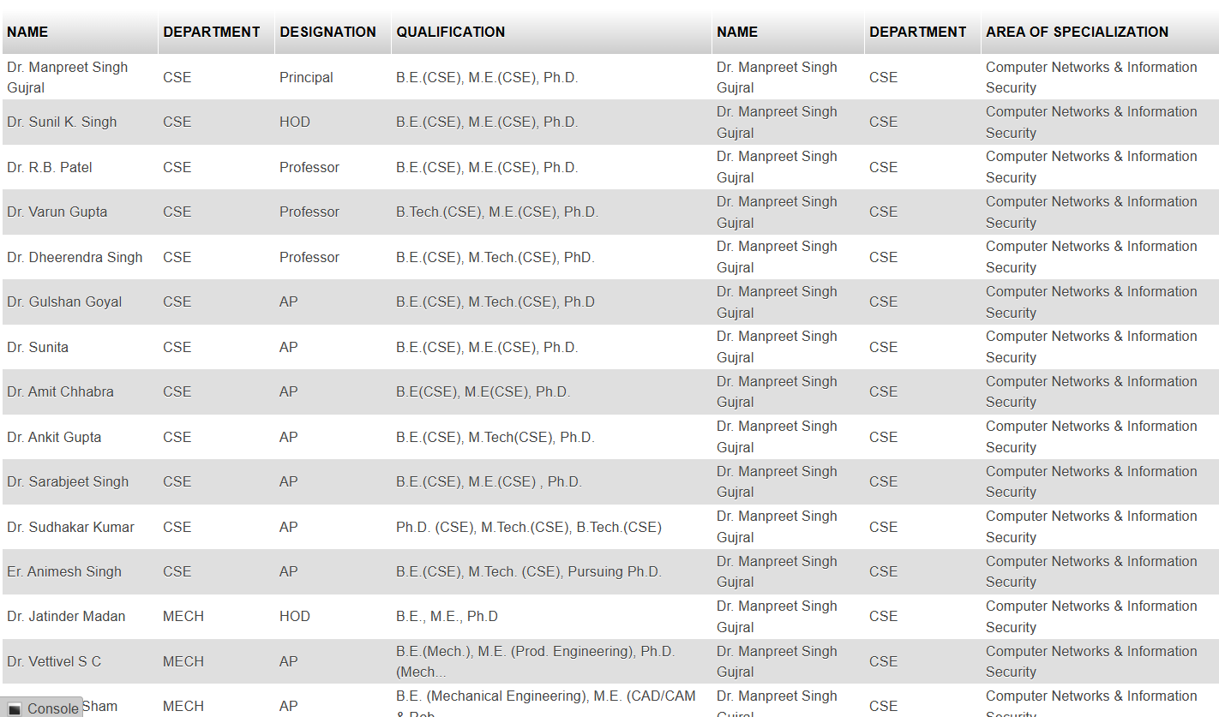

Query-13: equality operation
SELECT NAME,PHONE_NO FROM faculty_data___staff_info
WHERE PHONE_NO < SELECT MAX(PHONE_NO) FROM faculty_data___staff_info)
Table after operation
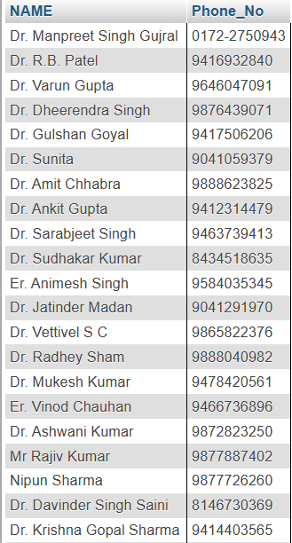

Query-14: Max/Min operation

SELECT MAX(Phone_No) FROM faculty_data___staff_info

Table after operation
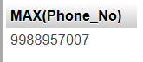

Query-15: Minimum operation
SELECT MIN(Phone_No) FROM faculty_data___staff_info

Table after operation

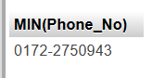

Query-16: Natural Join

SELECT *
FROM `faculty_data___staff_info`
NATURAL JOIN `printer_issue_detail`;

Table after natural join
